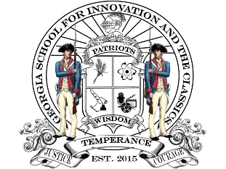

**Hephzibah Charter Foundation**

***(Georgia School for Innovation and the Classics)***

***Meeting Agenda for November 17, 2021***

**CALL TO ORDER**

1. **Administrative Functions** 
   * Approval of Agenda
   * Approval of Minutes
2. **School Related Reports**
   * School Report
3. **Financial Reports**
   * Monthly Financial Reports
4. **Old Business**
   * GSIC Expansion Update
5. **New Business**
   * Thanksgiving Bonuses
   * Family Leave Policy Adjustment
6. **Next Meeting Date**
   * January 18, 2022

**ADJOURNMENT**